Project Screenshots:

Teacher’s Login:

This is teachers login frame where username and password is already stored in database each teacher has username and unique password.

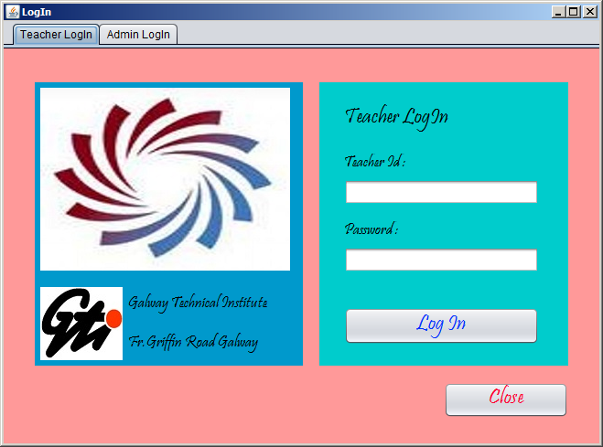

Admins Login:

This is admins login where username is admin and password is admin123.

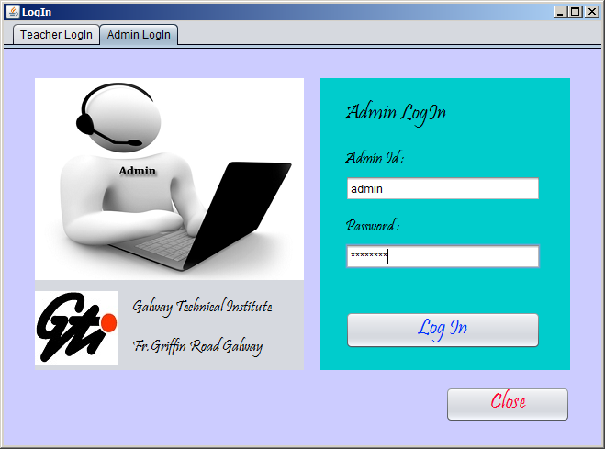

Main menu:

This is main menu where only admin has access has a wide range of options to access different frames by just clicking the button.

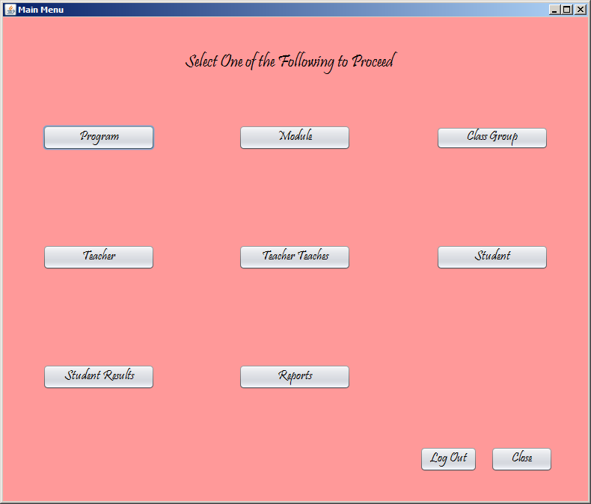

Program Frame:

This is the program frame where on the windows activation all program stored in database shows in JTable and there are several ways to search the program.

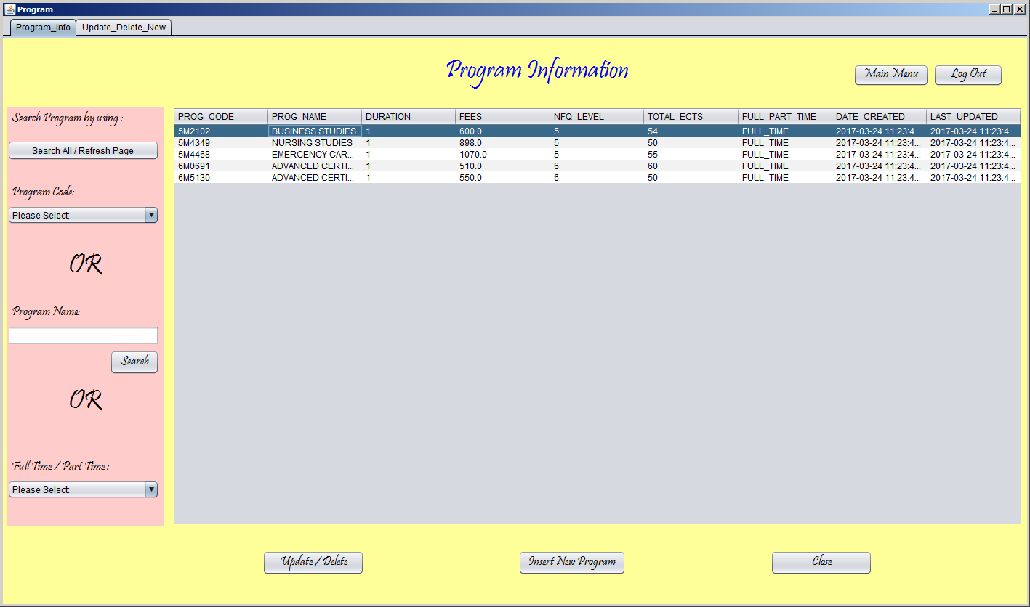

This is second tab of the program frame where admin can add delete or update the program by just inserting the information in the text fields and hitting the desired button.

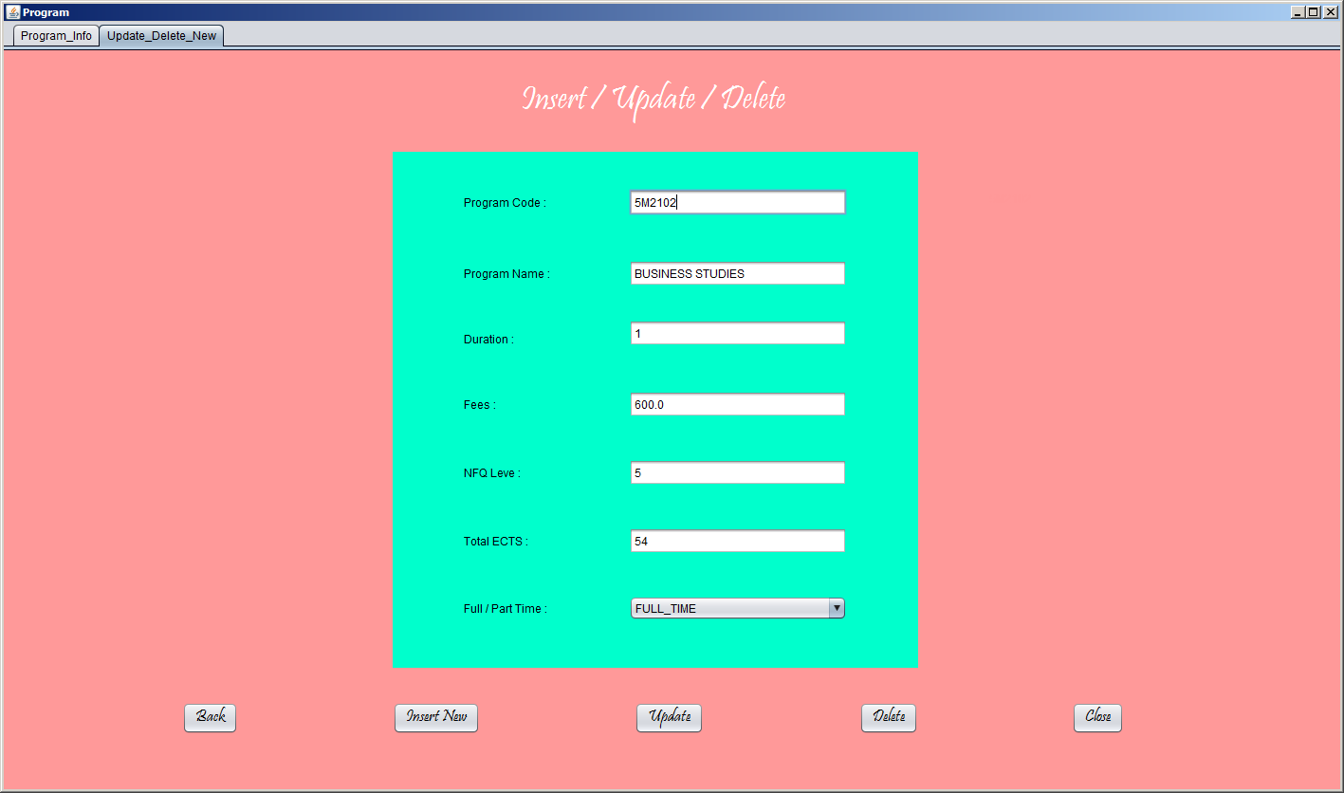

If admin click on JTable’s any row that action will populate that rows information in the related text fields and choose the related information from combo box.

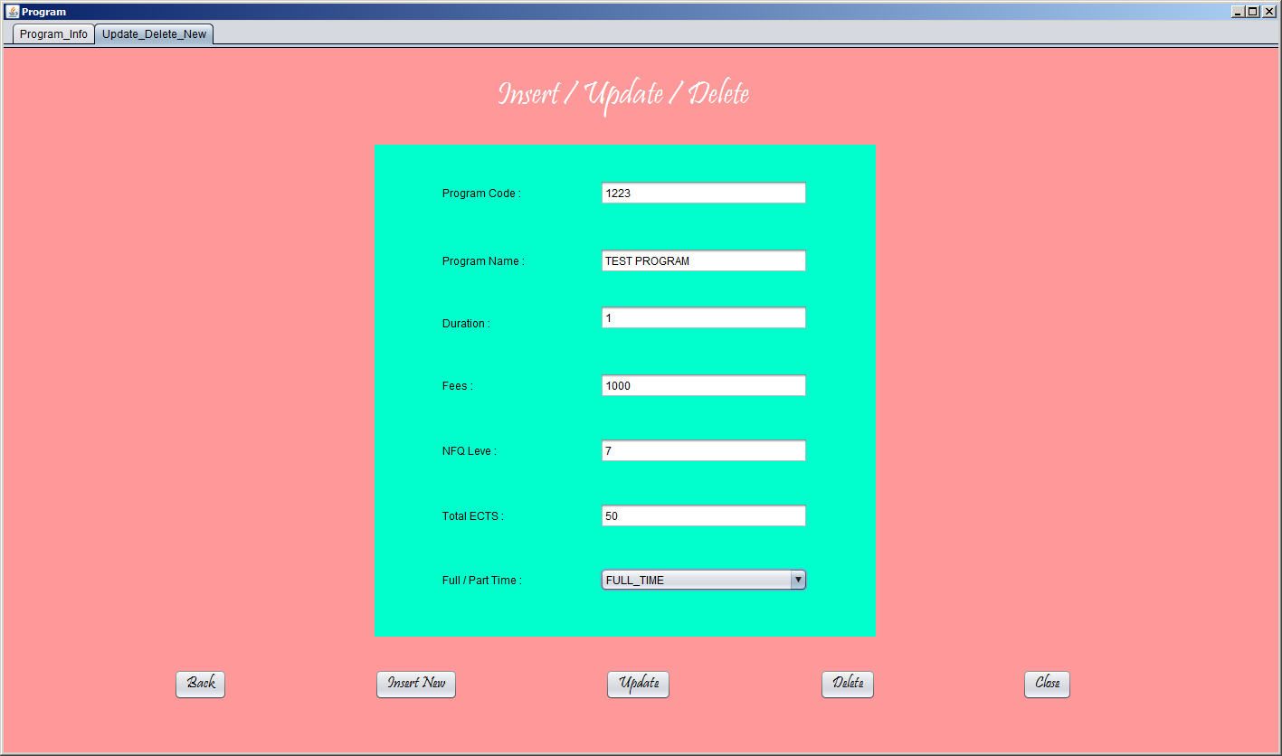

If admin fill the information in text fields and select any item from combobox and hit insert new button that will add a new program in the database and gives this message.

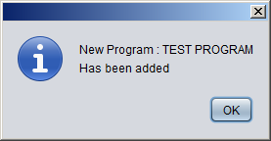

If admin select a row in the JTable and hit the delete button

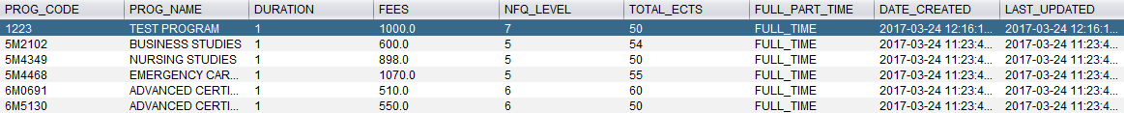

That will delete selected program from table in database and shows this information message

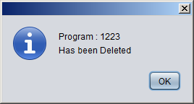

Selected program has been deleted.



If admins select a row any make any change and hit the update button



That will update the existing program and gives this information message

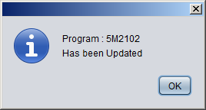

All the frames works as program frame worked there are few more screenshots of each frame.

Module Frame:

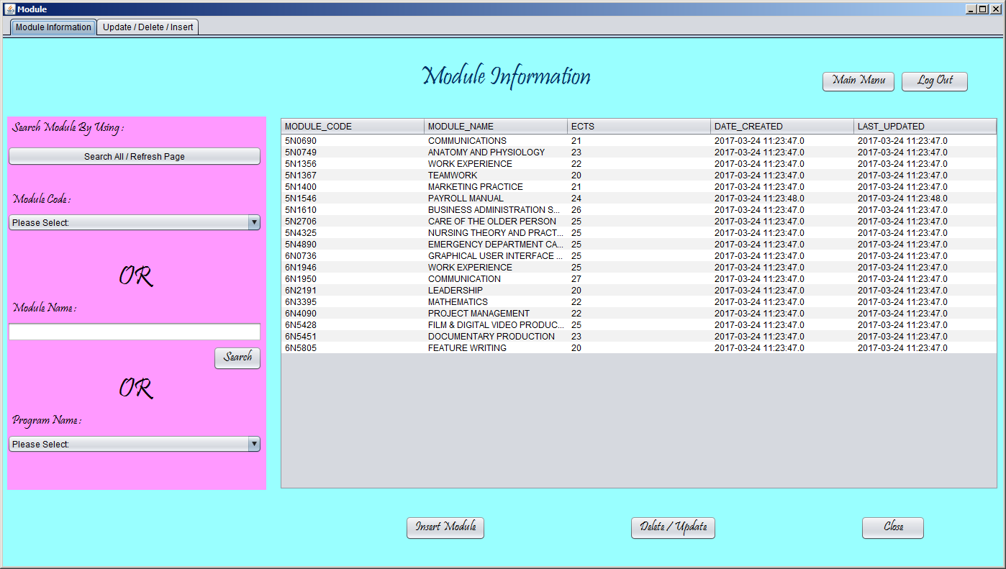

Module searched by the program name:

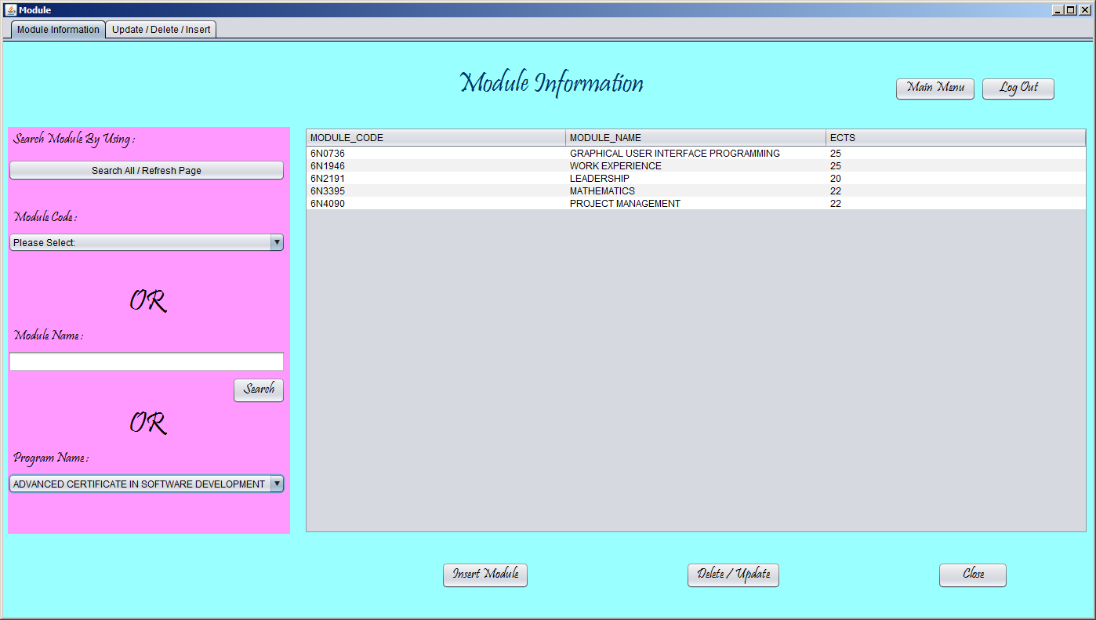

Insert Update and delete the modules using the GUI frame and insert in the intermediate table Prog_Module by selecting the name of the module or the codes of the module and program.

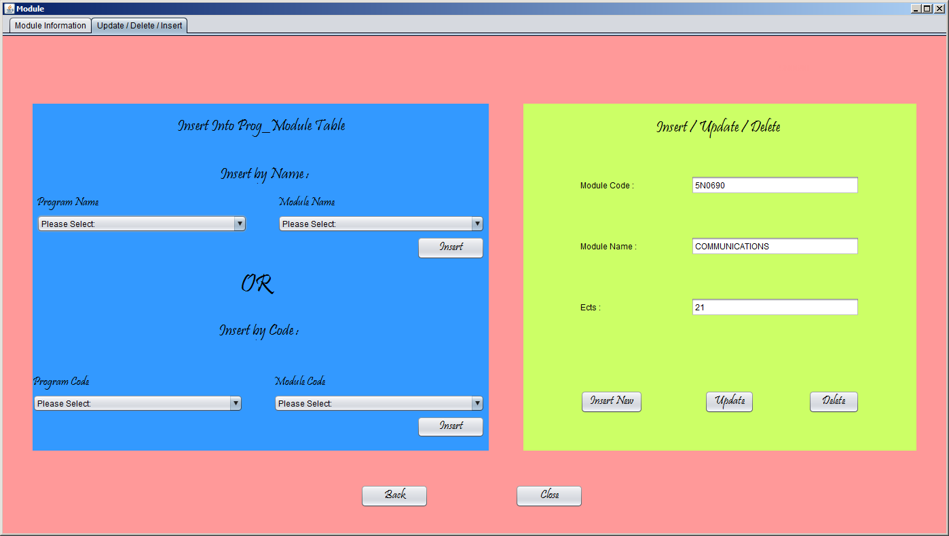

Class Group Frame:

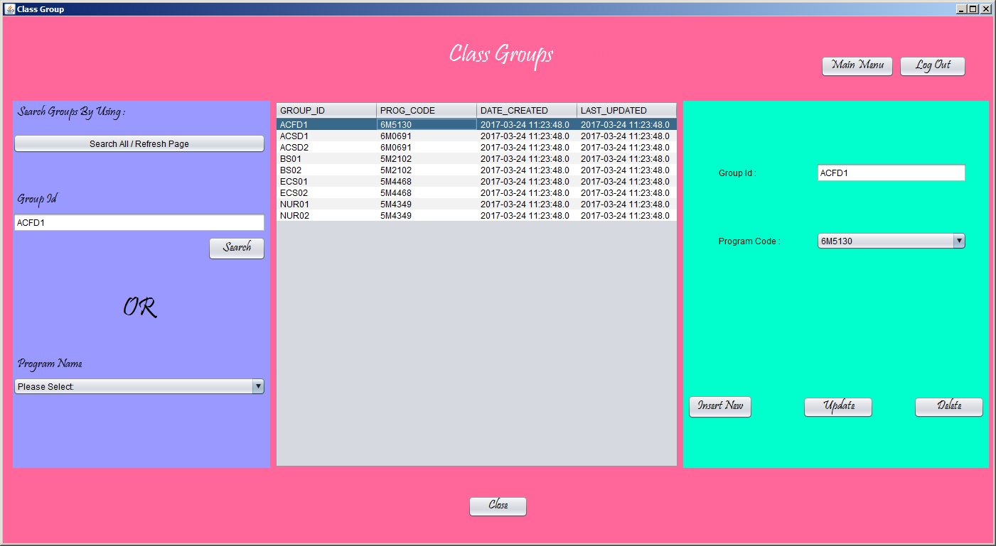

Teacher’s Frame:

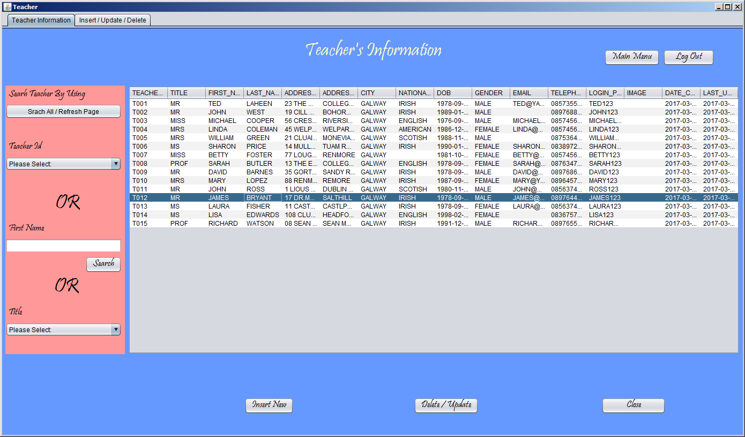

Admin can update delete and add new teacher and can save information in database.Teacher’s picture can be uploaded from the computer and can be uploaded and saved in database

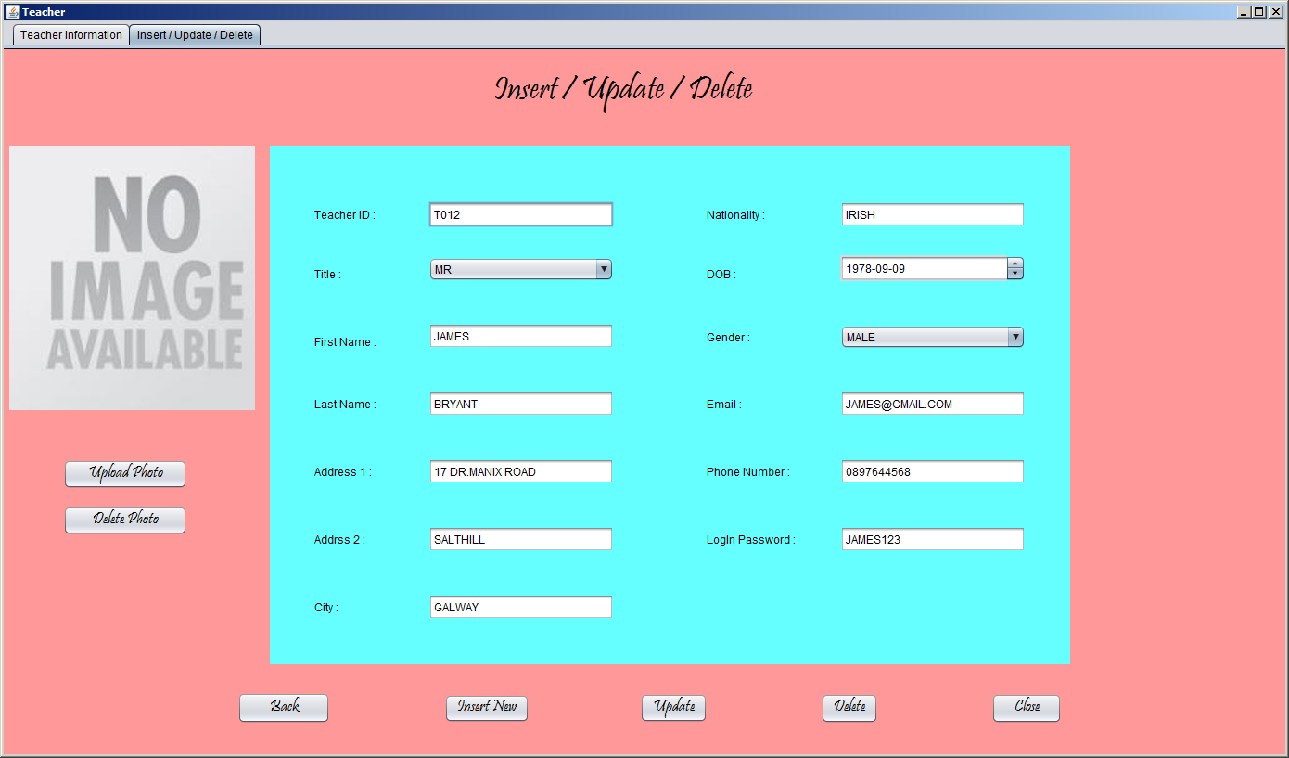

This is default window where admin can search and upload a teacher picture from computer.

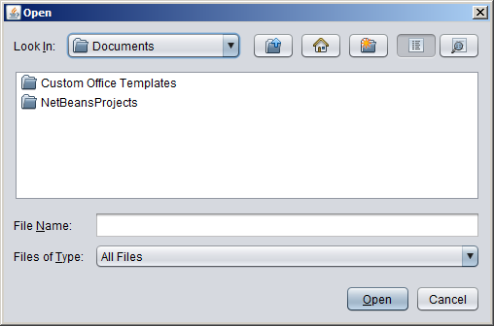

Teacher Teaches Frame:

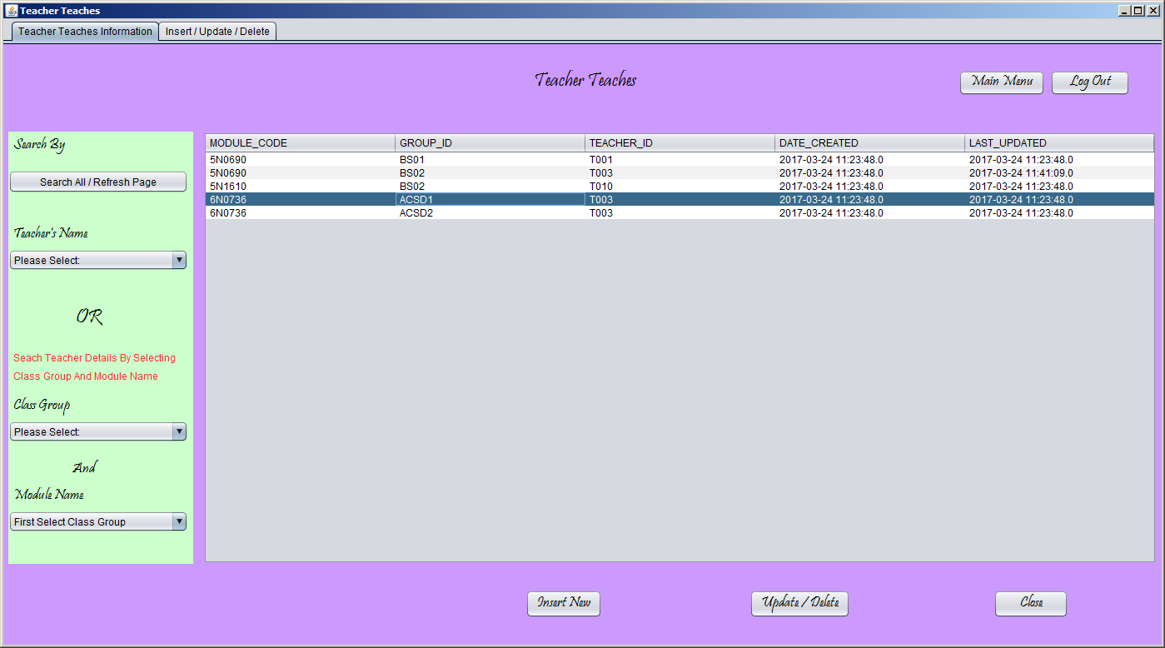

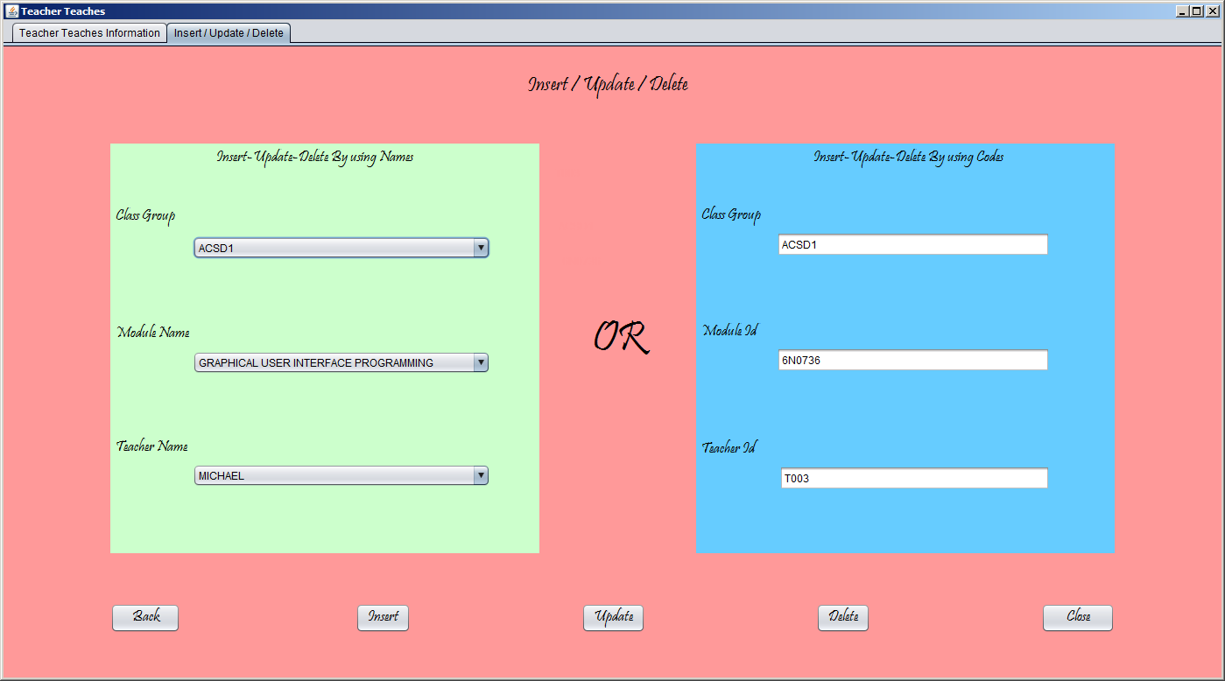

Teachers information can be accessed by just selecting class group and module name

(Which teacher is teaching which class group and which module)

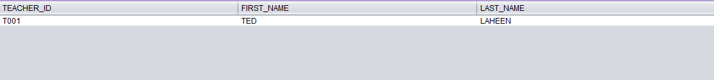

Student Frame:

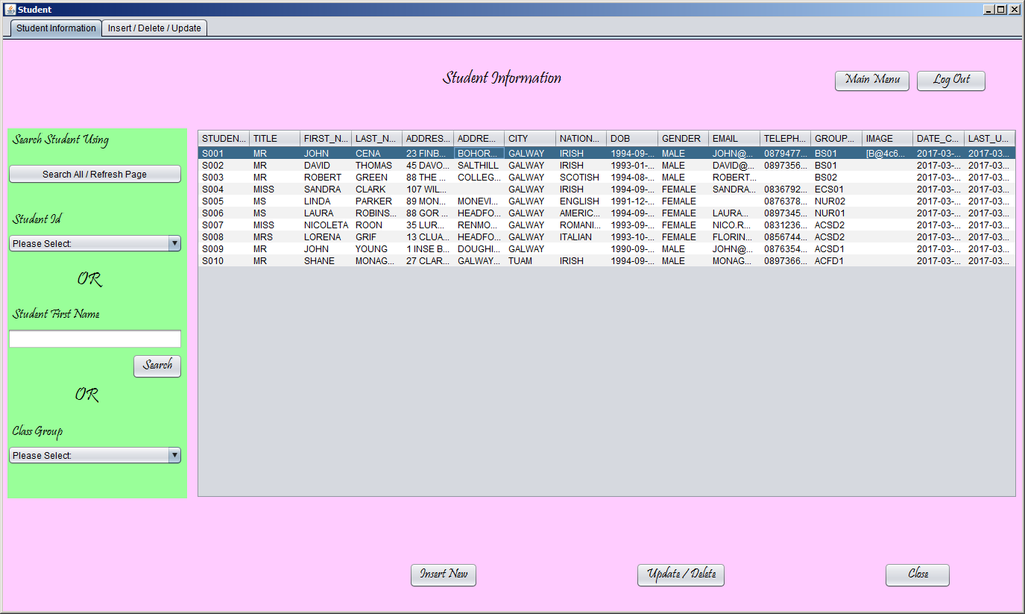

Student’s can be searched by just selecting the class group it will show the students information related to the selected class group

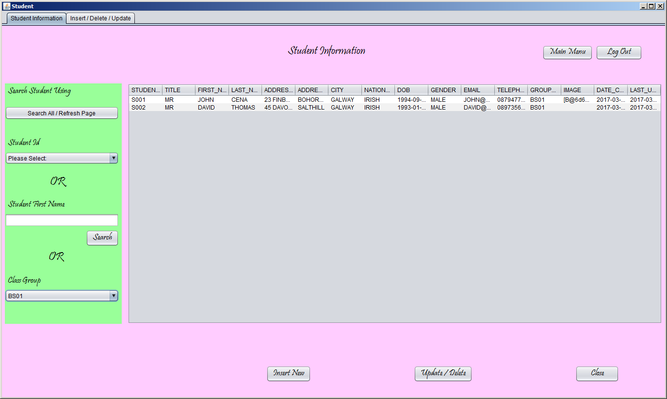

Student update delete and insert new Frame

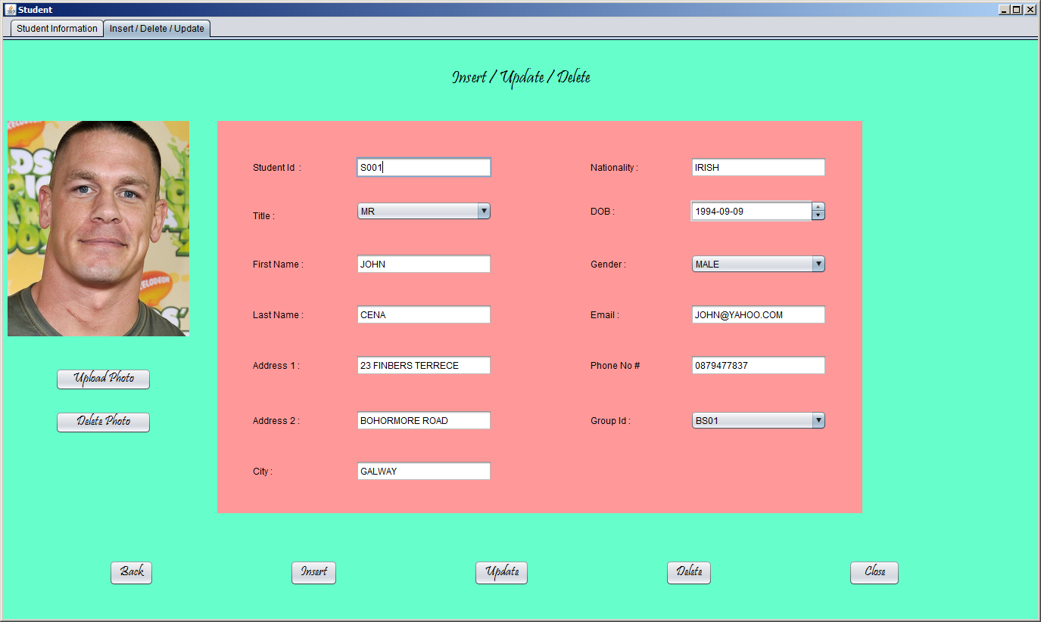

Student Results:

This frame is only for admin where admin can only see the students results but not allowed to insert update or delete any result.

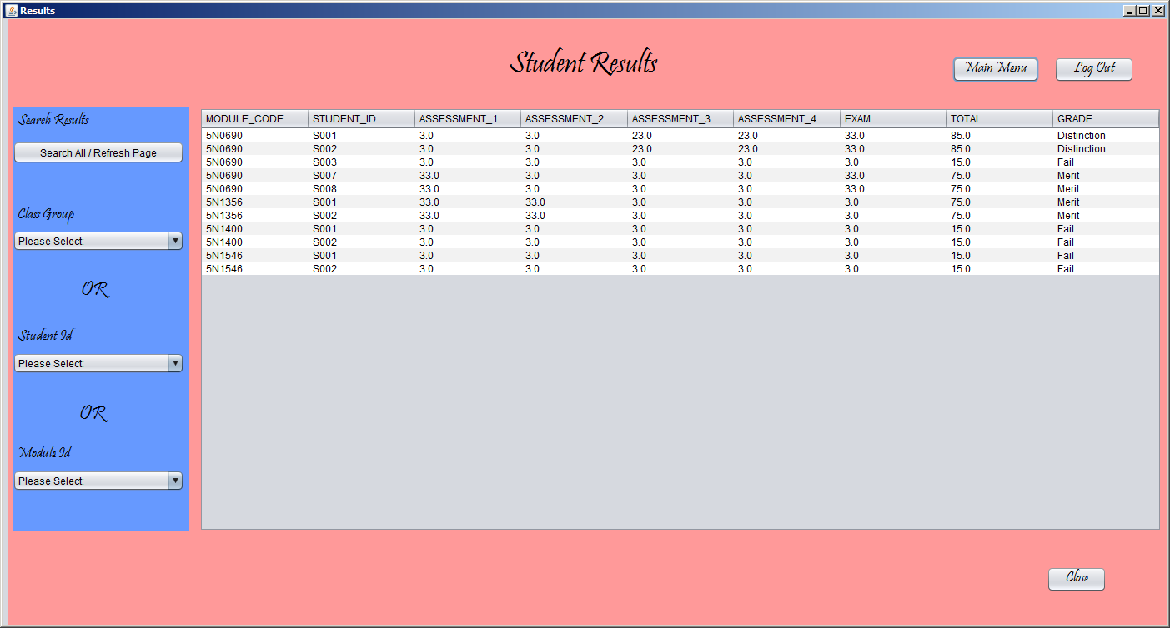

Students Resul:

This student result frame is for teacher where teacher can insert search update or delete any result of any student.

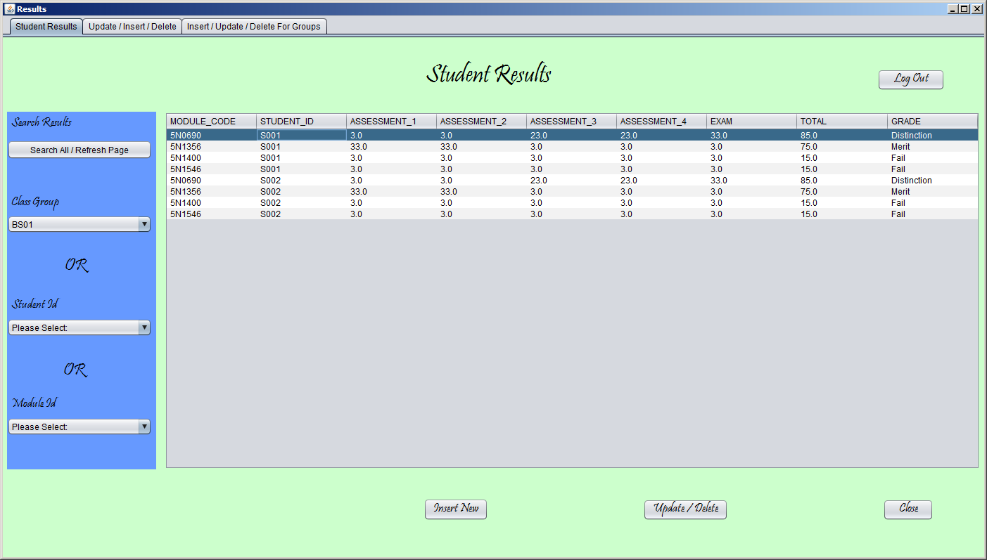

If teacher insert the module code and student id if the results already exist in the database that will populate the fields otherwise fields will stay blank

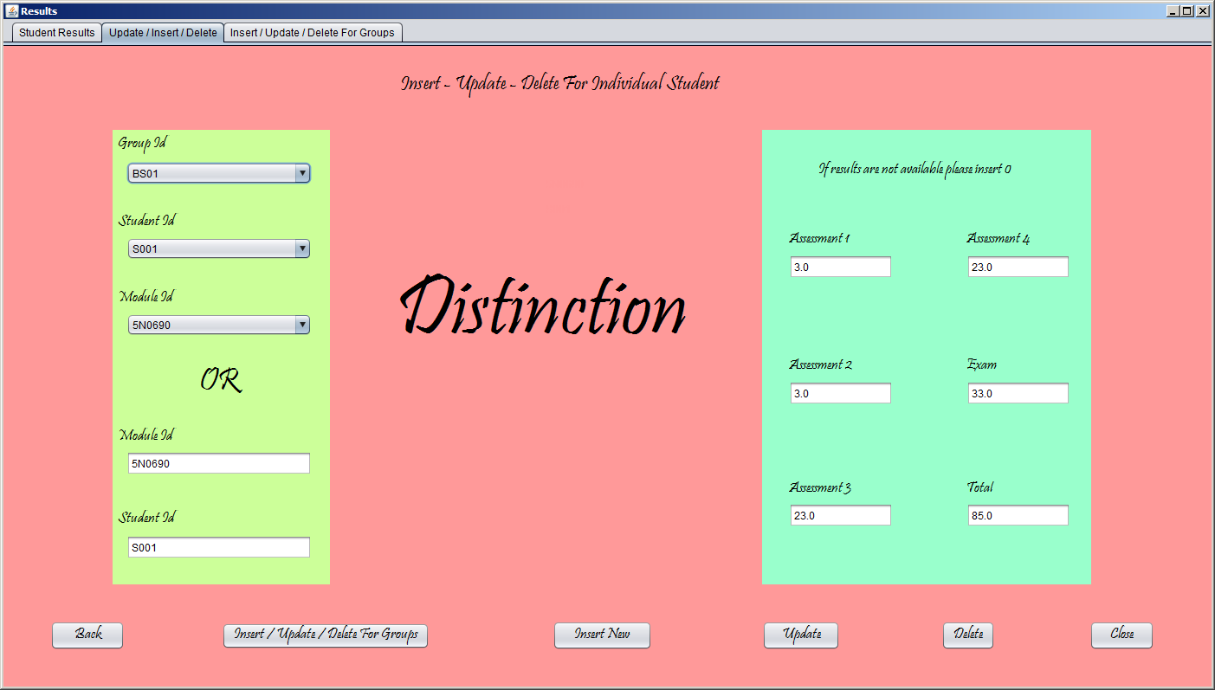

Insert update and delete results for class group:

If teacher select a class group it will populate the list with the related students and if user click on the row that will show the students all results in a table.

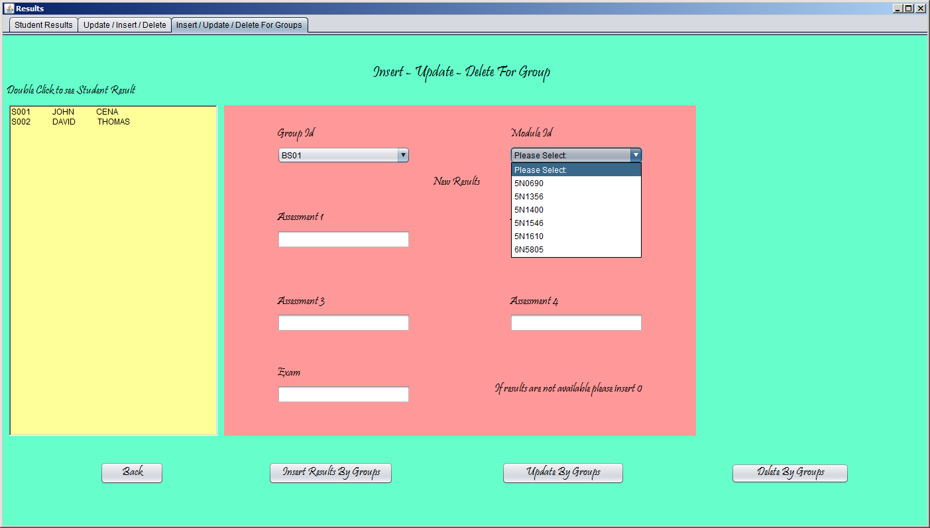

Reports:

This is reports frame where admin can generate many reports.

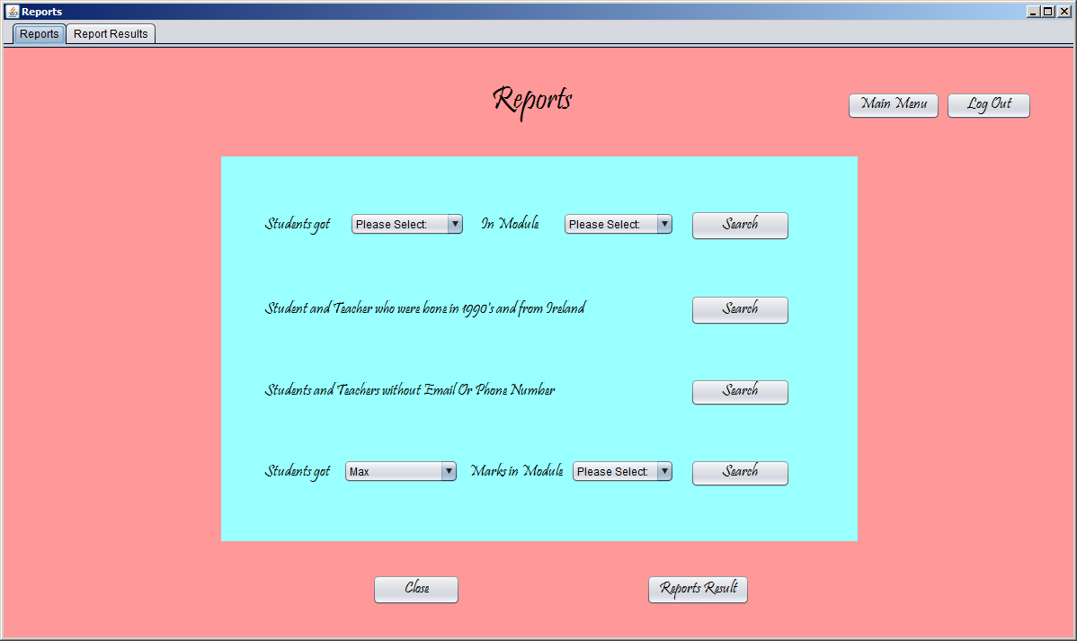

Reports results are shown in this table where admin can print the results of the specific report by just clicking a button with connected Printer or save reports in the computer.

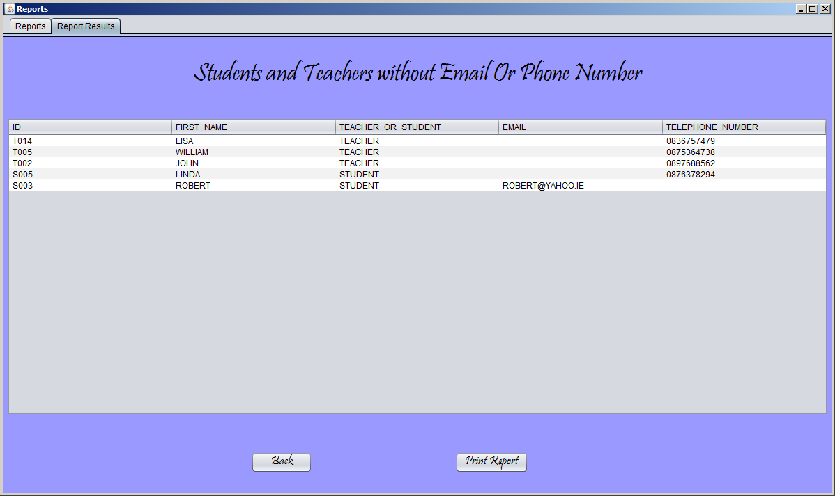

Page setting or printer selection:

